What is YeldnIN app ?
YeldnIN is the internal back-office platform for "Yeldn Health", an Egypt-based company that sells vitamins, supplements and health devices (brand: Egypt Vitamins / EGV) plus a second business line called XOONX (a global "order anything from world stores" service). The company sources products from suppliers abroad (USA / UK / EU) and brings them to Egypt mainly by travelers who physically carry items on trips, then delivers to customers via its own couriers.

Workflow
Customer wants a product → Sales logs a Request → Purchasing places supplier Purchase → Items ship to a destination Office abroad (to Transfer to a Traveler later) or to destination Traveler (To ship to Egypt in a Trip) → Logistics/Operations teams receive, pickup and photograph the incoming Shipments (Trips After Arriving to Egypt) in Egypt → items go "on website" → Couriers deliver to the customer. Around this run Pricing, Expenses/Finance, Issues & Compensations, History, Settings, and Users & Privileges.

It is bilingual (English + Arabic, full RTL), an installable PWA with web push, and integrates with an external storefront ("Veeey") which is a full eCommerce platform.

Golden Conditions that apply throughout the whole applications:
- Whenever there is photo attachment to any container or unit, users can add photos by uploading, pasting or drag & drop. Photos should appear as thumbnails on the page and user can click photo to show the big size photo. Users don’t need to download photos to show them. Users can upload multiple photos.
- Users in sales team should never have any access to logistics and purchasing. They shouldn’t know anything about Trips or Travelers.
- Application Unites (containers – from requests to shipments, items – items (products), and people – customers) should be interconnected so that users can click the name of any unit to go to its page. There are links for all connected units that user can click to go to these units. Connected units are units that have connections or relations with the current unit.

Categories of modules
The application consists of 3 main types of modules; (These categories don’t affect workflow at any time).
- Services – Pricing and Expenses
- Supply Chain – Sales, XOONX, Logistics, Operations, Couriers, History, Issues and Compensations
- Human Resources – Human Resources
- Administration

Users categories,
- Super Administrators
- Administrators
- Users

Teams
- Sales
- XOONX
- Purchasing
- Logistics
- Operations
- Couriers
- Development
- Human Resources

Modules
Main Modules
- Pricing
- Expenses
- XOONX
- Sales
- Purchasing
- Logistics
- Operations
- Couriers
- Issues
- History
Human Resources
- Human Resources
Administration
- Users
- Setting

Entry Fields for each unit
Customer
- Customer [Name] – short text input - Required
- Contact [Channel] – select from list; What’s App, Phone, Direct, Facebook and Instagram. Default Value is What’s App – Optional
- Contact [Number] – short text input – Optional

Product
- Product name
- SKU
- Scope, choose from list; Egypt Vitamins, XOONX and Personal. Sales and purchasing teams can add products of scope Egypt Vitamins only. XOONX and purchasing teams can add products of scope XOONX only. Admins can add all products
- Product Type, select from list; Supplements, Devices, Injection, Heavy Supplements and XOONX
- Default Supplier, select from list of suppliers. Write the country of each supplier next to his name on this list. Default value is Amazon – USA, UK or EU
- Weight (g)
- Size
- Grade
- URL
- Notes
- Is Male Support? Switch
- Product Images – upload, paste or drag and drop
Please follow attached UI
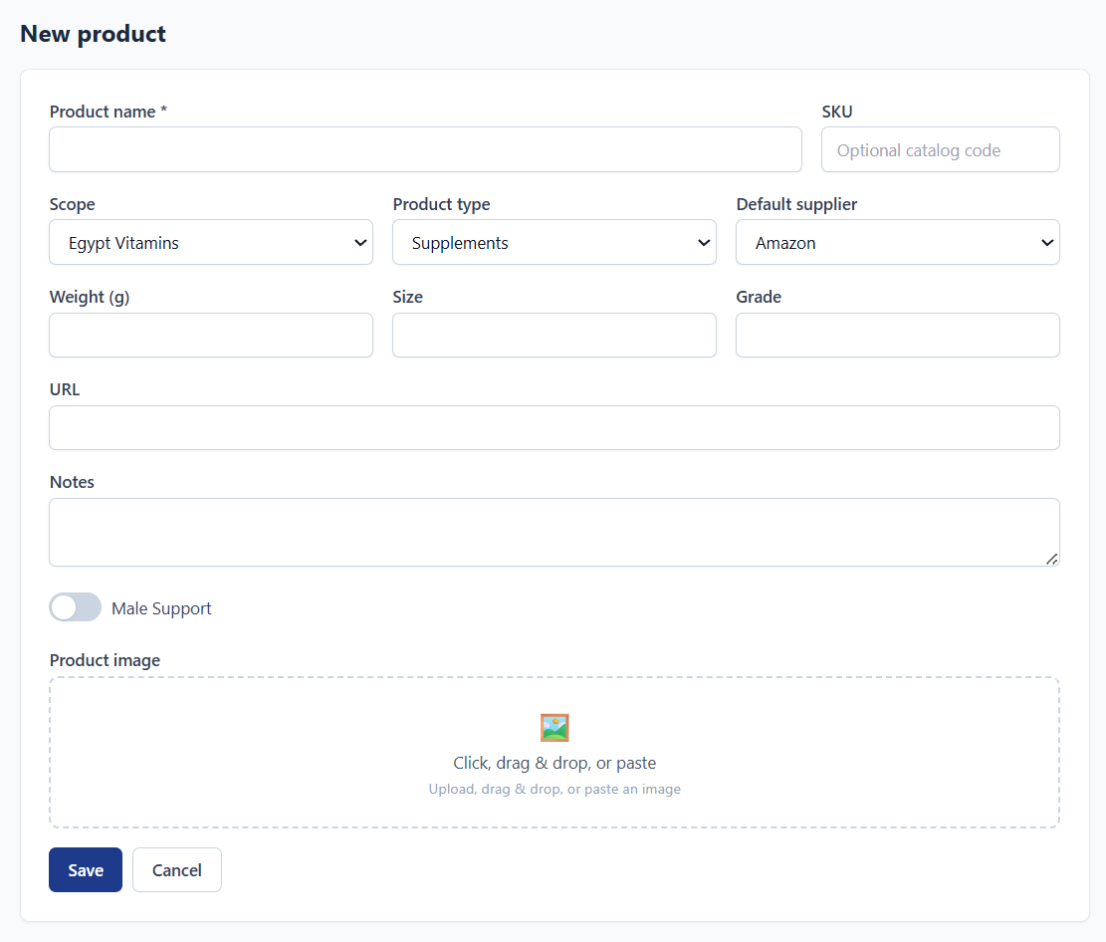
Request
- Request Type, select from list; Special Order, Out of Stock, Restock or Optional – Default Value is Restock
- Special orders require sales users to add Customer. Sales users can create customers directly in same page
- Products; User can add multiple products to same request. User
  - Product – select from list of all products
  - Count
  - Selling Price
  - Purchase Price
- Notes
- Photos – only if Request Type is Special Order
Please follow UI below
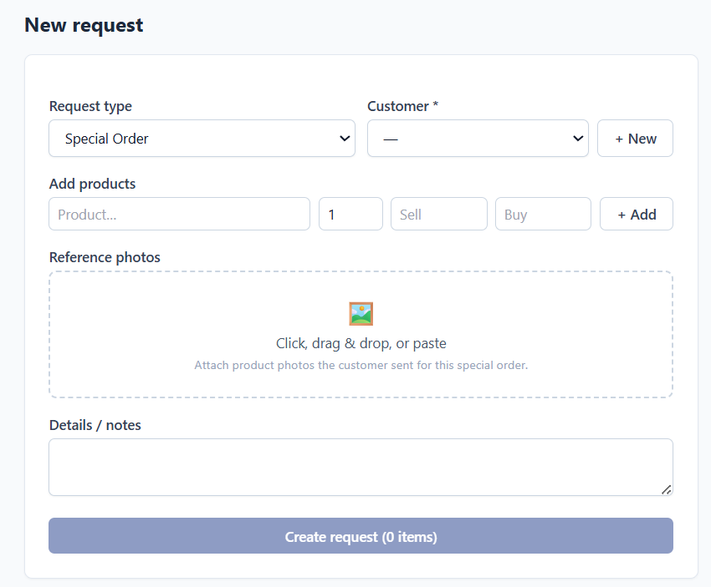
Purchase
- Scope; show list of available scopes that have request pending purchase
- Country, show list of countries that have available requests pending purchase in previously selected scope
- Supplier; show list of suppliers who have available requests pending purchase in previously selected country and scope
Put the previous 3 choices in same row next to each other
- Purchase Price
- Destination Type, select between Hubs or Trip
- Destination, select from list of Hubs or Trips (as previously decided).
Put the previous 3 entries in same row next to each other
Notes;
- Users can’t purchase products that are not already requested and not patched yet
- Users can only Purchase products to trips that have status (Approved or started Shipping), and have Last Receiving Date not today and not in the history

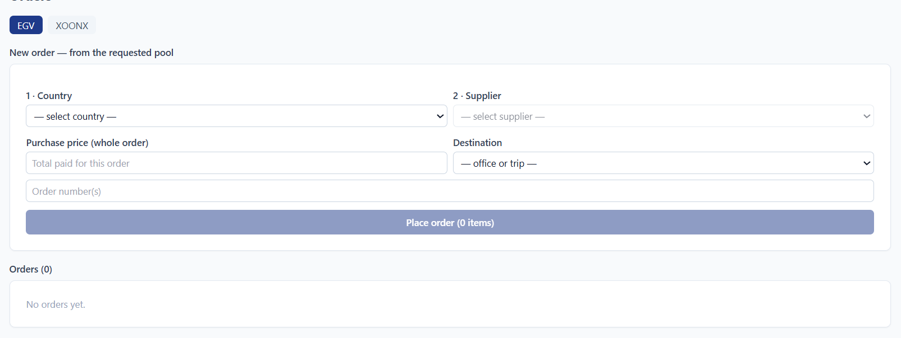
Patch (A shipment from Supplier to any Hub or Traveler)
- Country – inherit from Purchase
- Supplier – inherit from Purchase
- Dispatch Date – date of creation on the system – auto stamp
- Delivery Date – date of changing status to Delivered on the system – auto stamp
- Tracking
- Courier – pick from courier list
- Items – pick from list of items in the purchase
- Notes
- Photos

Transfer (A shipment from any Destination (Hub or Traveler) to another Destination (Hub or Traveler))
- Date created
- From Destination – hub or traveler/trip
- To Destination – hub or traveler/trip
- Items in transfer
- Note
- Photos

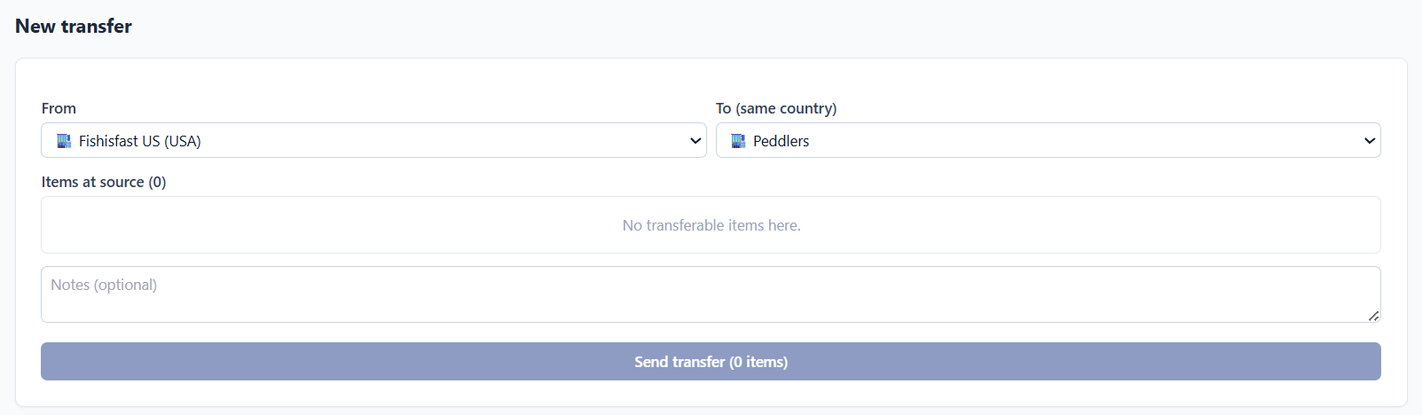
Shipment (Part of or all of Inventory items of a Trip when it arrived to Egypt and our operation staff pick up it) – Auto generated by the system

Hub
- Hub Name – required
- Country – select from list of available countries – required
- Notes – optional
- Attached photos – optional
- Each hub has inventory, which is all items stored in that hub
- Users (logistics) can transfer inventory from hub to another destination (hub or traveler / trip) in same country
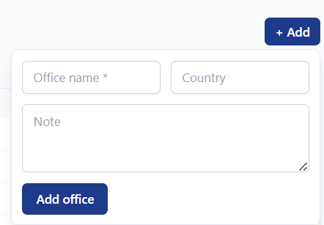
Traveler
- Traveler [Name]
- Contact
- Notes
- Photos
- Reference – Select another traveler
- Active or Inactive
- Blacklisted?
- Static Address?
- Carries Male Support?
- Allowed product types;

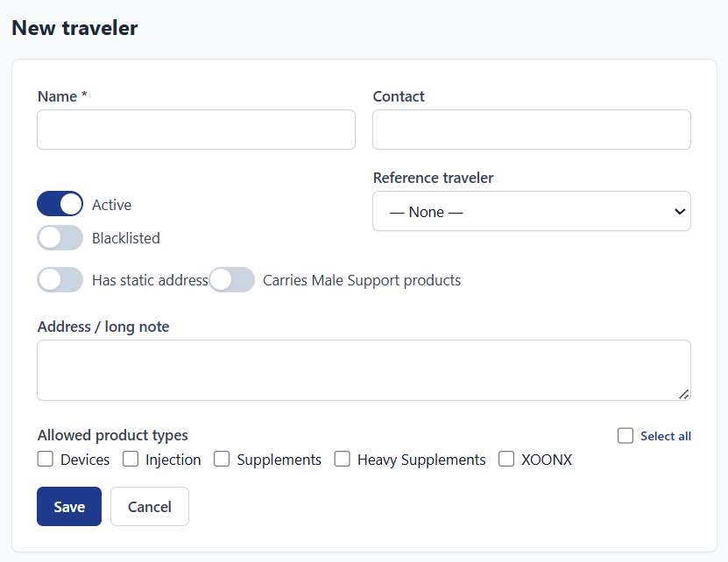
Trip
- Country
- Traveler, select from list of all travelers
- Max Weight
- Deal price per KG
- Last Receiving Date (Deal with it as (Trip Date))
- Delivery Date in Egypt
- Allowed product Types – as in UI – inherit from Traveler details
- Male Support – as in UI – inherit from Traveler details
Notes – inherit from Traveler details

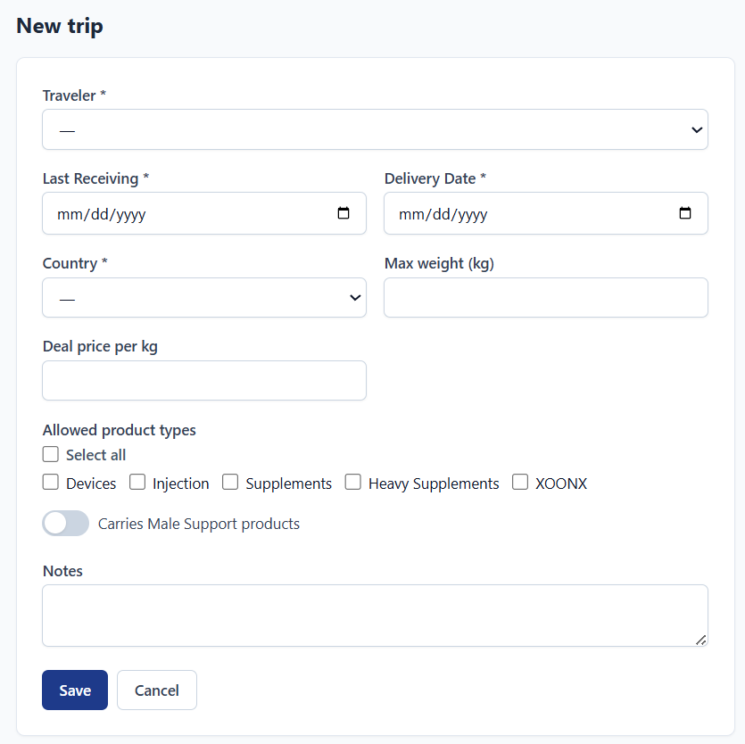

Permissions
- There must be a matrix of permission that allows me to grant any permission to any role
- Purchasing and Logistics users can view requests and products only
- Purchasing users can add new products, logistics users can’t

Details
- All requests from same scope show as Pool of Pending requests. Purchasing users Purchase products from this pool. Purchased products deduct from this pool. If purchased marked as cancelled, it will return to the pool. If item marked as Lost or Damaged, it would return to the pool again.
- Traveler and Trip have the same inventory. The inventory is interchangeable between them. If a traveler has inventory and has a trip, then all inventory is allocated or added directly to his nearest trip. If the trip arrived to Egypt of picked up but some items (of inventory) were delayed or didn’t arrive. Then, these items of inventory will return back to the inventory of the traveler.

Units
Items, products, partners or users, they are the building block of the system while tracking inventory items from point to point.

The scenario

Containers
Containers are baskets that carry the items from point to point during their pathway from supplier to customer. Supplier is the starting point, and customer is the ending point. In some cases, the item (product) lifecycle starts with a customer and ends with the customer. This case happens in Special Order – where customer ask us to buy a product for him and we go to supplier and order the product and handle the product from container to container till we reach the customer back.

Supplier
- Request
- Purchase
- Patch
- Traveler
- Trip
- Hub – optional
- Transfer – optional
- Shipment
- Office
Website
Products go from website to customer through these steps;
- Order
- Delivery
- Courier
Customer
And 3 other optional containers
- Lost
- Damaged
- Errant
And flags;
- Delay – this flag can be added manually or automatically through some predefined conditions

Statuses
Sales Side

Items have any of the following statuses. (Lists of statuses or lifecycle steps are editable by admins in the backend.
- Requested – added to request by sales or XOONX or admin users
- Purchased – added to Purchase by purchasing users
- Dispatched – Added to Patch from supplier to any destination (Hub or Trip/Traveler)
- Delivered – The supplier or the courier from the supplier told us that the item id delivered.
- Received – Hub or Traveler confirmed receiving the items (or items)
- Hub – Item is stored in hub until shipping globally to Egypt. We mark all items as (Hub) after being received in our hub / traveler with 2 to 4 days. The period is random by system.
- Transit – this status happens when an item stays in the Hub for 4 – 6 days. The period is random by system.
- Customs – once Trip containing item status change to (In Egypt)
- Out for delivery – once Shipment containing item status change to (Ready to Pick up)
- Office – once Shipment containing item status change to (Picked up)
- Photos sent – Once operation user updated shipment details and updated Expiry dates of items and attached photos and changed status to Photos Sent
- Website – once sales users mark shipment as

Trip Methodology (Very Important)
- We know some travelers who travel frequently from USA, UK and EU to Egypt.
- We send them purchases from our suppliers and they carry them in their trips to Egypt
- Travelers confirm that they have received the items in purchases
- Logistics users follow up with travelers
- When traveler arrive to Egypt, Logistics team notify Operation team to pick up the inventory of the trip – which should be all inventory with the traveler
- In some cases, travelers leave some items abroad and don’t bring in their trips
- In this case, delayed or forgotten inventory will remain with travelers and leave the trip. – Inventory marked delayed after the date of the trip

Trips to Shipments
- Once trip arrive in Egypt and become ready for us to pick up, the system will notify operation users to pick up that Trip.
- Once Operation users Picked up the trip, they should upload photos of the picked-up from the trip
- Once Trip is picked up by operations, operation will upload photos attachments. These photos are editable by operation and admin users only.
- Operation users should review the trip inventory – compare actual items picked-up (from the Trip) to items in the trip on the system. Also, Logistics team and Purchasing team should review the picked-up trip. All 3 teams (one employee from every team – and if one did, then the shipment will move forward) must mark the shipment as;
  - OK
  - Issue – should write note of the issue in this trip and attach photos of the related items.
- Each mark (flag) should be shown by its team only
- Admin can see all marks in a single row in the top of the Trip details page and next to trip details in list of trips page;
For example; Purchasing (OK) – Logistics (OK) – Operations (Issue)
  - Upon clicking on (Issue), it will show the note and attached photos.
  - Users who see the Issue can open the note to show details of the issue and show photos in big size view
  - Issue automatically opens an issue in Issues and Compensations Module
- Each team’s users can see only his mark – admins see all marks
- Admins should approve the trip to release and convert to shipments. Next to the 3 marks there should be two buttons; OK (Which will convert trip to shipment/s) or Hold (Which will keep holding the shipment and notify all team to review the shipment again)
- All marks and approvals should be tracked and logged by the system. Admins can see this log
- Users can change their mark from (OK to Issue or vice vers) until the shipment is approved by admins.
- Logistics team can move some items from the trip (on the system) to the traveler – mark delayed. They can also notify other users who marked the shipment to review and mark again.
- If the trip have approved (OK) by admin users, the trip will create new shipments and move its inventory items to the created shipments as follows;
  - If the trip has any items for XOONX scope, create a separate shipment for all XOONX items – only XOONX and admin users can see these shipments in XOONX module.
  - If the trip has any items for Personal scope, create a separate shipment for all Personal items – only admins can see these shipments in Shipments module.
  - If the trip has any items for Egypt Vitamins scope, check the number of the items;
    - If the count of items is below 20 items (1 to 19 items), then create a separate shipment for all Egypt Vitamins items – only Egypt Vitamins and admins can see these shipments.
    - If the count of items is 20 or more, split the shipments to multiple shipments and distribute items on these shipments as follows;
      - Minimum count of items in shipment is 10 items
      - Maximum count of items in shipment is 19 items
      - Each shipment can’t have more than 5 items of same product. And we prefer to keep the count of items of same product around 2 or 3 items of same product
      - If there are more than 3 items of same product, please distribute items evenly or near evenly between shipments. So that each shipment contains 2 to 5 items.
    - The count includes only supplements and Heavy supplements
  - Operation users can upload detailed photos of these shipments.
  - Operation users can update Expiry dates of all items in the shipment
- Once operation team uploaded detailed photos of the shipment, they should change shipment status to (Photos Sent)
- Shipments with status (Photos Sent) will appear in shipments Section in Sales module
- Sales users should change status to (Website) to close the cycle of the Item and Trip.
- Trips with issues will keep in list of trips – issues section and keep in issues list in issues and compensation module till been solved.

Life cycle of Containers and Items – please find attached Excel sheet.
"C:\Claude\YeldnIN\Status.xlsx"

Trips
Statuses
- New
- Approved
- Started shipping
- Completed shipping
- Completed Receiving
- Waiting trip
- Traveling
- In Egypt
- Ready to pick up
- Picked up
- Photos sent
- On website – Complete
- Cancelled
Flags (Totally – all inventory of the trip or Partially – some items in the trip)
- Delayed
- Errant
- Lost
- Damaged

Shipment (a trip with status Ready to pick up or advanced)
- Out for Delivery = Ready to pick up
- Received = Picked up
- Photos sent

Order
Statuses
- Ordered
- Dispatched
- Delivered
- Received
Flags
Flags (Totally – all inventory of the trip or Partially – some items in the trip)
- Delayed
- Errant
- Lost
- Damaged

Flags
- Flags for Items – this reflect on Partial flag for the container
  - Delayed
  - Errant
  - Lost
  - Damaged
- Flags for Containers – this reflect on flags of all items in the container
  - Delayed
  - Errant
  - Lost
  - Damaged

Compensations
- In case some items are lost or damaged, supplier or traveler may give us compensation of that item.
- Suppliers compensate with replacement items and traveler compensate with money
- Compensations from suppliers will be new Purchases with Purchasing Price 0. They will be sent to any destination as normal Purchases
- Users can create compensations from issue page directly and select Compensation Type; Product or Money
  - If compensation type is money; allow user to enter amount of money in EGP
  - If compensation type is product; allow user to select items from lost or damaged items

Gifts
- Gifts are items received with Purchase
- Suppliers send them for free
- Purchasing and Logistic users can add products as gift to Purchases – by selecting products and adding the count of each product and add notes and photos

Friendly Names
All containers should be viewed in the application with Friendly Names, as follows;
- Supplier >> Suppler Name
- Request >> In case of Special Order; 3 X Requested from Supplier to Customer by Sales User, In case of non-Special Order >> 3 X Requested from Supplier by Sales User
- Purchase >> 3 X Purchased from Supplier to Destination
- Patch >> 3 X Shipped from Supplier to Destination
- Traveler >> Traveler Name
- Trip >> Traveler name . Date (which is Last Receiving Date)
- Hub – optional >> Hub Name
- Transfer – optional >>
- Shipment >>
- Office >> Office Name
- Website
- Order
- Delivery
- Courier
- Customer
And 3 other containers
- Lost
- Damaged
- Errant

